Pitch Proposal – Listener

I am going to build a podcast web app, that would allow the user to keep track of their podcasts with ease.

As a listener to podcasts I would like to build a website that allows a more visual way to choose podcasts than my current podcast app of choice the default iTunes app:

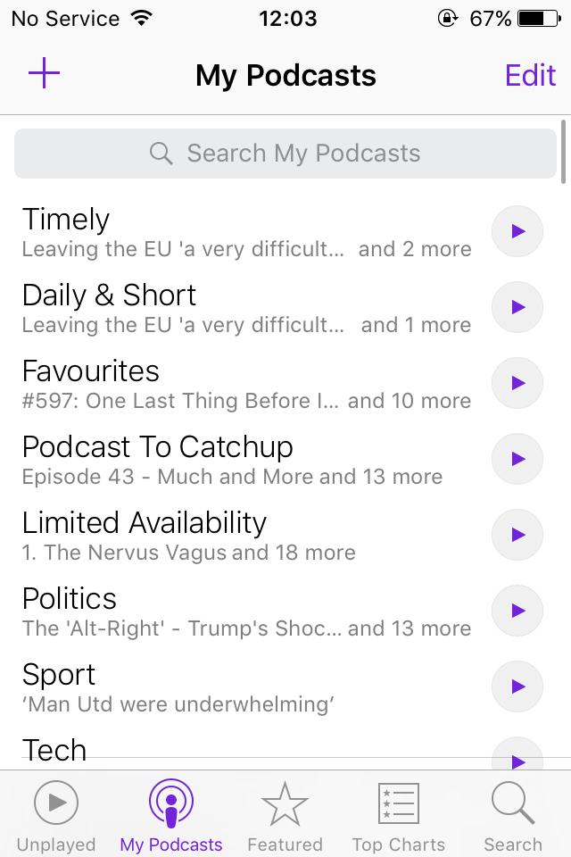
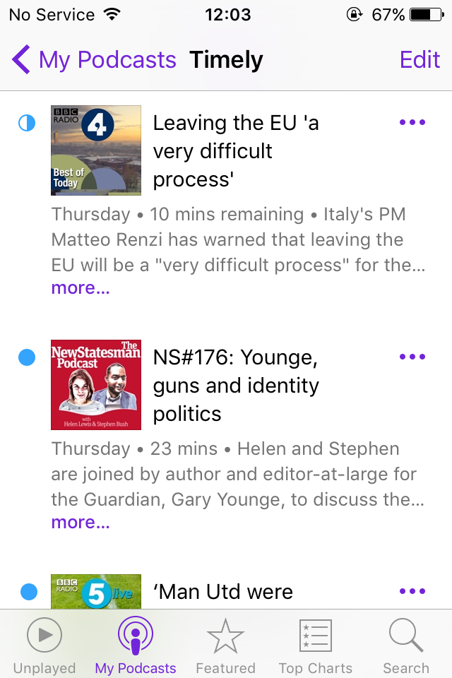

Another problem I have with the iTunes app is that doesn’t display the artwork embedded with the podcast app I would like to display this when available.

To do this I propse building the web app ‘Listener’ to allow users a more visual way of absorbing podcasts.

Database:
The database will contain 3 collections: User, Subscription/Podcasts and Episodes.

The User collection will store the following information for each listener:
username
password
podcasts subscribed
the played status of each episode in that podcast
the last time played too? If possible/achiveable
default settings
refresh interval
episode limit (only show x episodes)
etc
date joined
date last login

The subscriptions/podcast collection will store the following information
Name
Info
Rss Feed
Episode ID
favourited

the podcast collection will store the following info:
parent sub
ep name
ep stream link
ep info
image
date uploaded

Wireframe (Desktop):
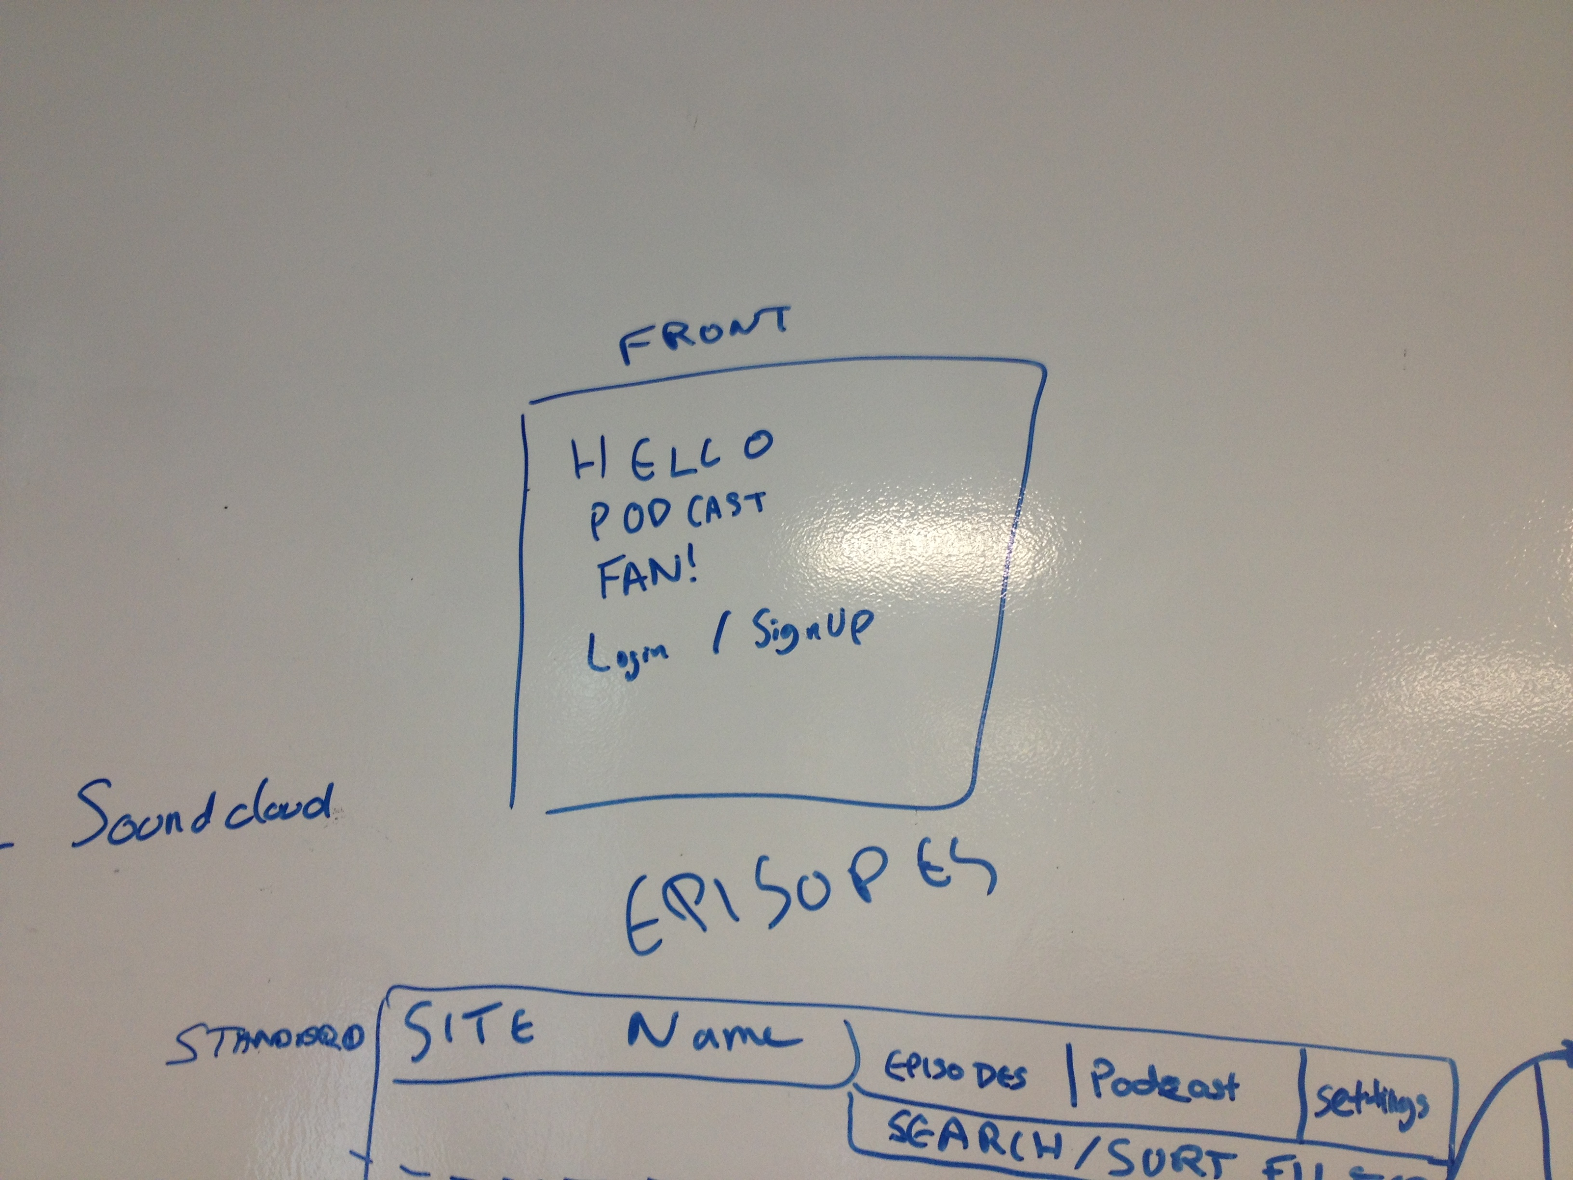
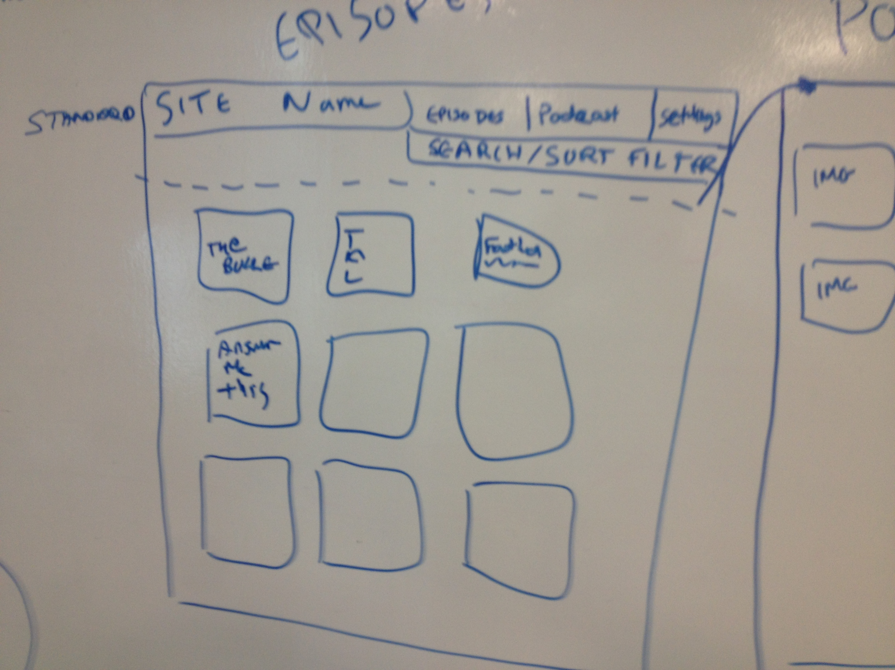

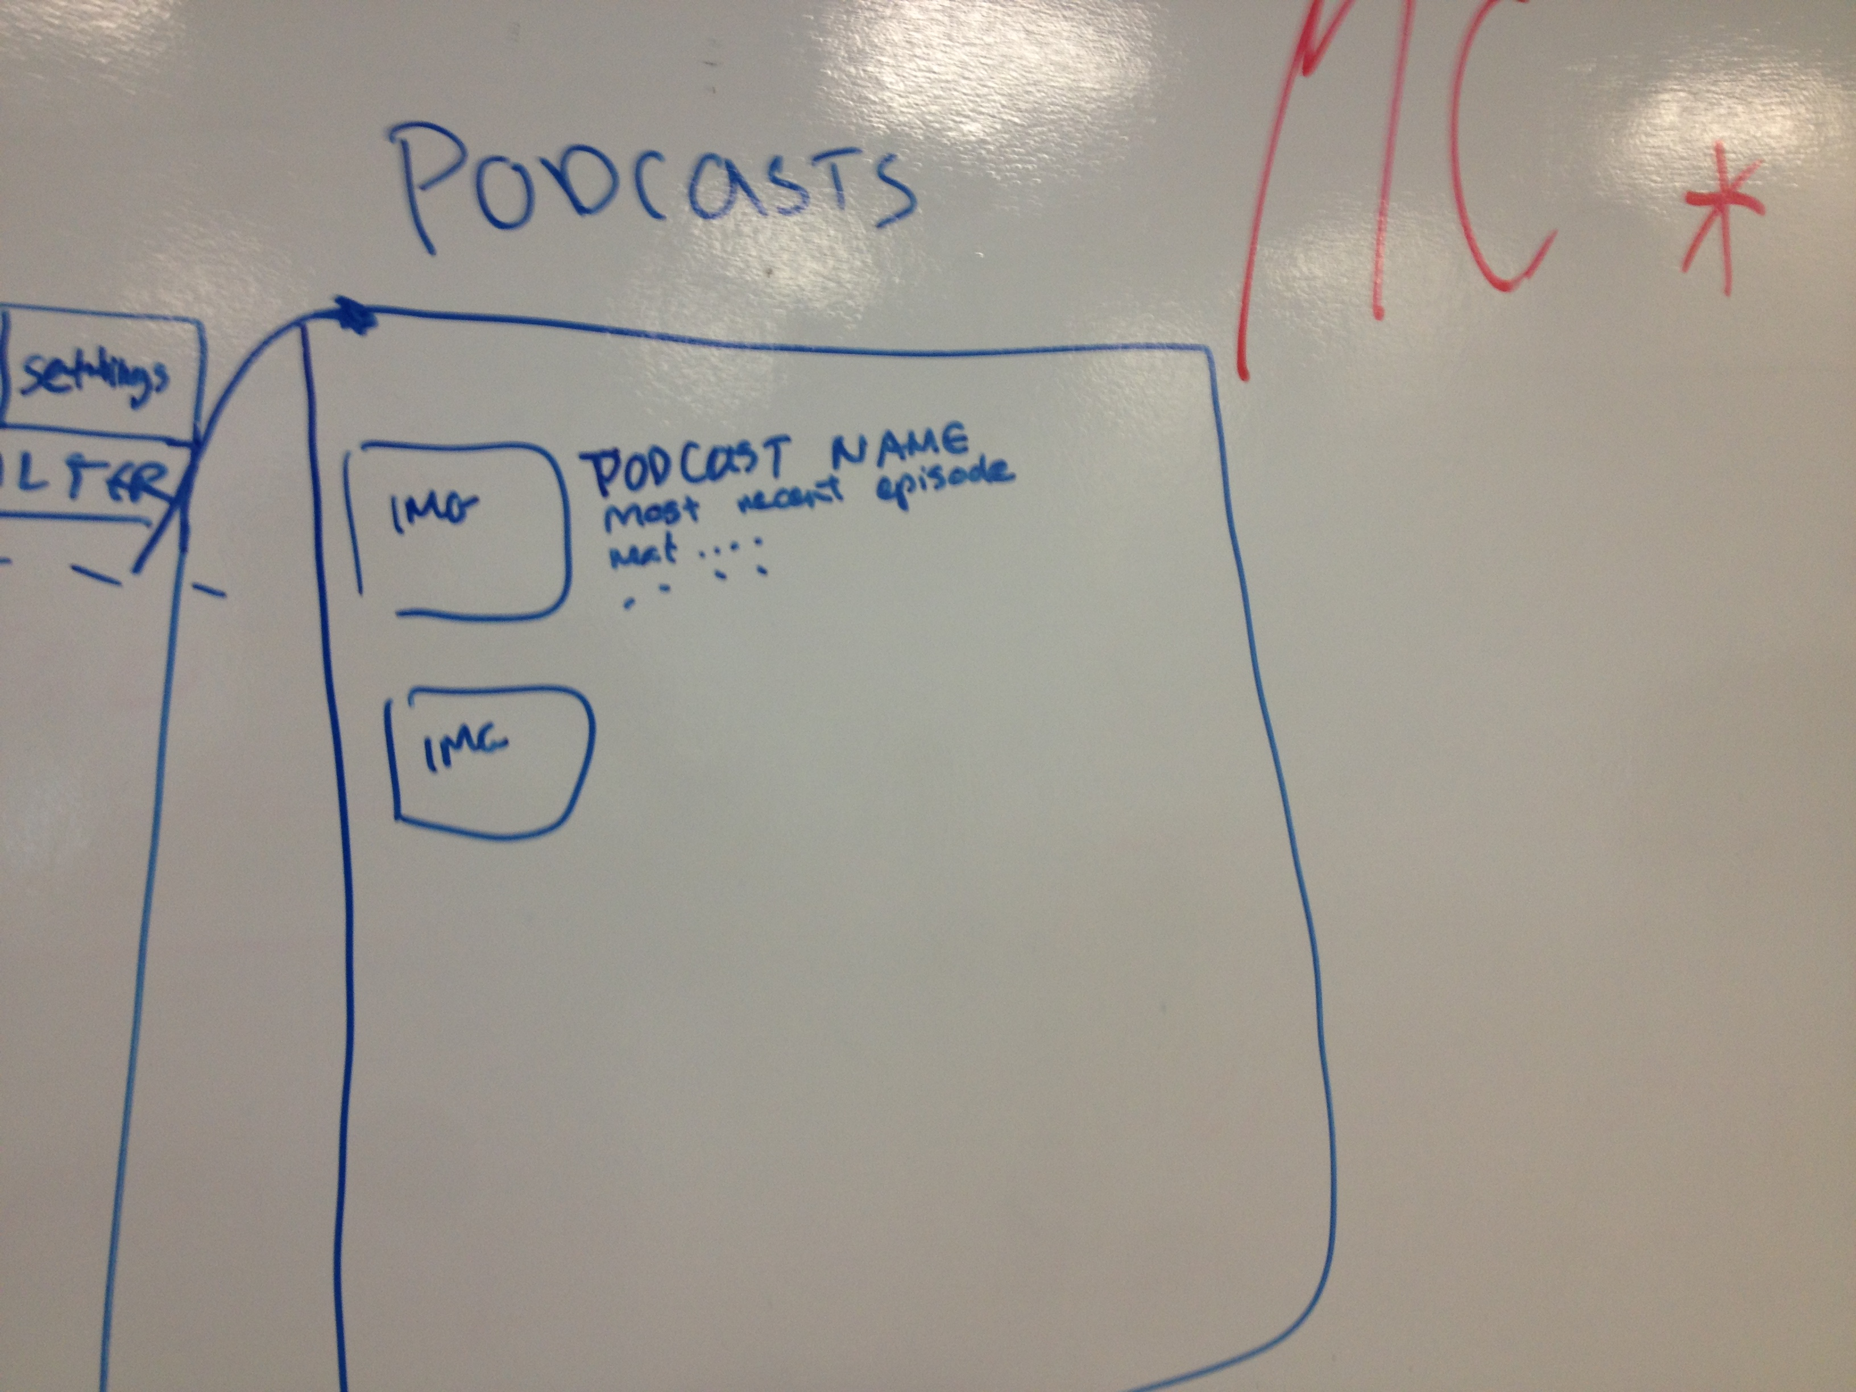

Wire Frame (Mobile):
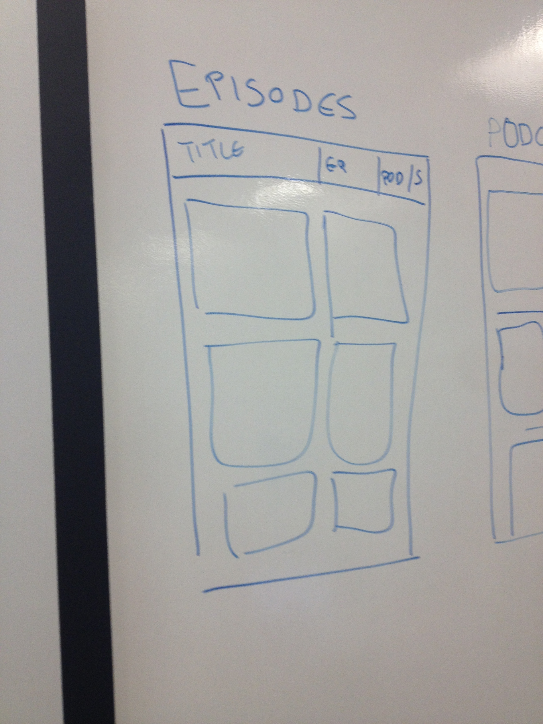

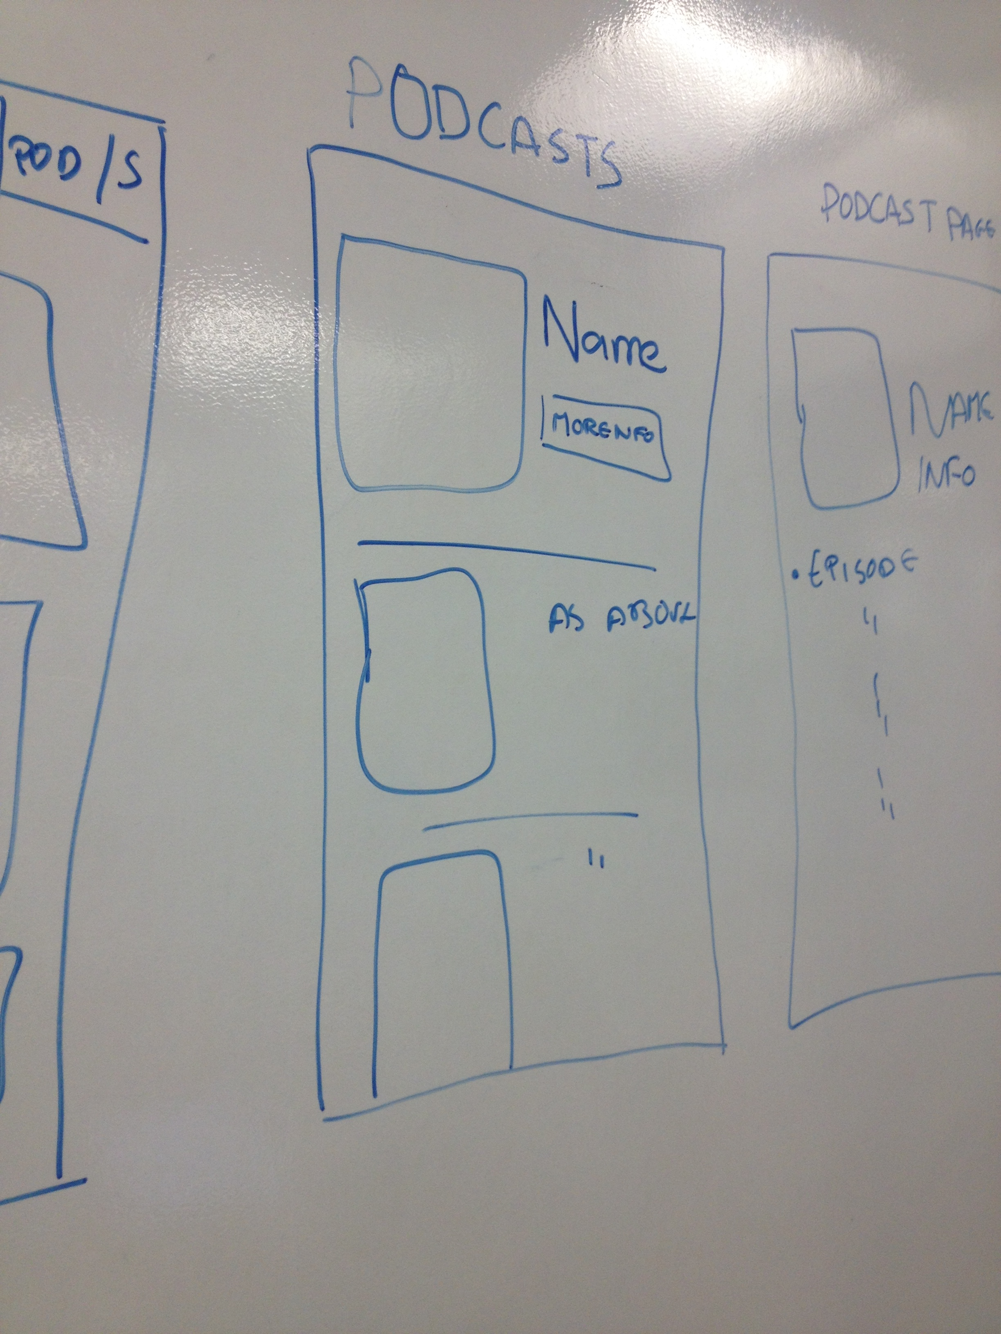

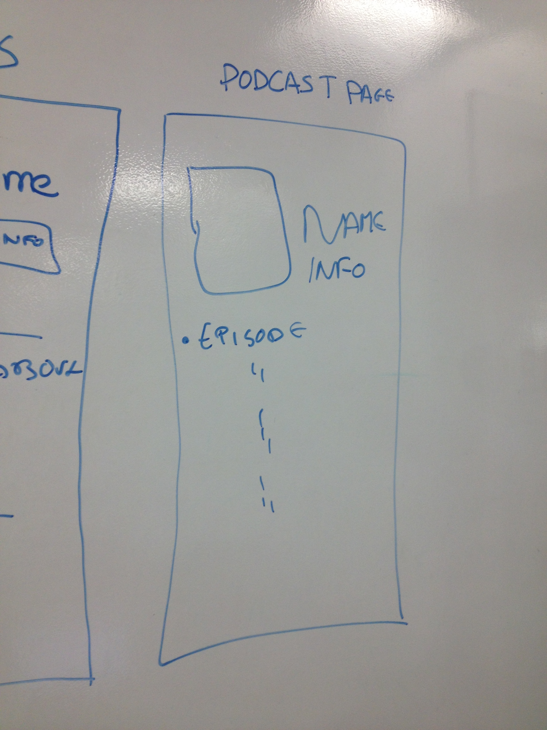

User Interactions:

After logging in/singing up the player will be able to:
- Add a new subscription
- Play an episode
- Mark an episode as played/unplayed
- Remove a subscription
- change the podcasts displayed on screen based on ‘factors’
- refresh the page to look for more podcasts (from what I’ve googled rss feeds and socket.io do not work together)
- logout

Bonus Targets:

- Dropbox link
  - Allow user to add non-podcast audio to page
  - Save podcast to dropbox (offline listening and for episodes that will not be available for all time, BBC or This American Life)
- Ability to add episodes from BBC or NPR etc
- Link to soundcloud to allow users to add more audio

